Practical No. 2
- Develop a program to display “Hello World” on screen.
Q.1] Write a Program to display “Welcome in Mobile Application Development World” on screen.

MainActivity.java :

package com.techtitans.madpracticals;
import android.os.Bundle;
import androidx.activity.EdgeToEdge;
import androidx.appcompat.app.AppCompatActivity;
import androidx.core.graphics.Insets;
import androidx.core.view.ViewCompat;
import androidx.core.view.WindowInsetsCompat;
public class MainActivity extends AppCompatActivity {
@Override
protected void onCreate(Bundle savedInstanceState) {
super.onCreate(savedInstanceState);
EdgeToEdge.enable(this);
setContentView(R.layout.activity_main);
ViewCompat.setOnApplyWindowInsetsListener(findViewById(R.id.main),
(v, insets) -> {
Insets systemBars = insets.getInsets(WindowInsetsCompat.Type.systemBars());
v.setPadding(systemBars.left, systemBars.top,
systemBars.right, systemBars.bottom);
return insets;
});
}
}
activity_main.xml :
<?xml version="1.0" encoding="utf-8"?>
<androidx.constraintlayout.widget.ConstraintLayout
xmlns:android="http://schemas.android.com/apk/res/android"
xmlns:app="http://schemas.android.com/apk/res-auto"
xmlns:tools="http://schemas.android.com/tools"
android:id="@+id/main"
android:layout_width="match_parent"
android:layout_height="match_parent"
tools:context=".MainActivity">
<TextView
android:id="@+id/txtMessage"
android:layout_width="wrap_content"
android:layout_height="wrap_content"
android:text="Welcome in Mobile Application Development World"
android:textSize="18sp"
android:textStyle="bold"
android:textAlignment="center"
app:layout_constraintTop_toTopOf="parent"
app:layout_constraintBottom_toBottomOf="parent"
app:layout_constraintStart_toStartOf="parent"
app:layout_constraintEnd_toEndOf="parent" />
</androidx.constraintlayout.widget.ConstraintLayout>

Output :-
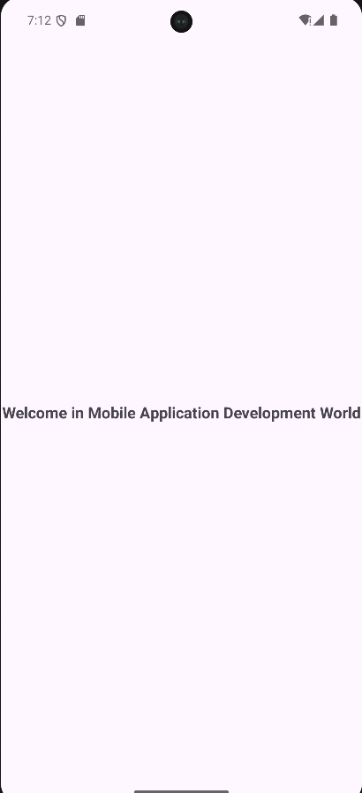

Q.2 Write a Program to display “I am interested to develop different Mobile Applications” on screen.
MainActivity.java :
package com.techtitans.madpracticals;
import android.os.Bundle;
import androidx.activity.EdgeToEdge;
import androidx.appcompat.app.AppCompatActivity;
import androidx.core.graphics.Insets;
import androidx.core.view.ViewCompat;
import androidx.core.view.WindowInsetsCompat;
public class MainActivity extends AppCompatActivity {
@Override
protected void onCreate(Bundle savedInstanceState) {
super.onCreate(savedInstanceState);
EdgeToEdge.enable(this);
setContentView(R.layout.activity_main);
ViewCompat.setOnApplyWindowInsetsListener(findViewById(R.id.main),
(v, insets) -> {
Insets systemBars = insets.getInsets(WindowInsetsCompat.Type.systemBars());
v.setPadding(systemBars.left, systemBars.top,
systemBars.right, systemBars.bottom);
return insets;
});
}
}

activity_main.xml :
<?xml version="1.0" encoding="utf-8"?>
<LinearLayout
xmlns:android="http://schemas.android.com/apk/res/android"
android:id="@+id/main"
android:layout_width="match_parent"
android:layout_height="match_parent"
android:orientation="vertical"
android:gravity="center"
android:padding="24dp"
android:background="#F5F7FA">
<TextView
android:id="@+id/txtTitle"
android:layout_width="wrap_content"
android:layout_height="wrap_content"
android:text="Mobile Application Development"
android:textSize="22sp"
android:textStyle="bold"
android:textColor="#1E40AF"
android:layout_marginBottom="12dp"/>
<TextView
android:id="@+id/txtMessage"
android:layout_width="wrap_content"
android:layout_height="wrap_content"
android:text="I am interested to develop different Mobile Applications"
android:textSize="18sp"
android:textColor="#111827"
android:textAlignment="center"/>
</LinearLayout>

Output :-
